**Aim:To Learn And Use SenseHat**

What is SenseHat?

The Sense HAT is an add-on board for Raspberry Pi, made especially for the Astro Pi mission – it launched to the International Space Station in December 2015 – and is now available to buy.

The Sense HAT has an 8×8 RGB LED matrix, a five-button joystick and includes the following sensors:

* Gyroscope
* Accelerometer
* Magnetometer
* Temperature
* Barometric pressure
* Humidity

**A sentence :**

Code:-

from sense_hat import SenseHat

import time

sense=SenseHat()

anycolor=(255,255,255)

sense.show_message("Hello ! I am nikhil")

OutPut:-

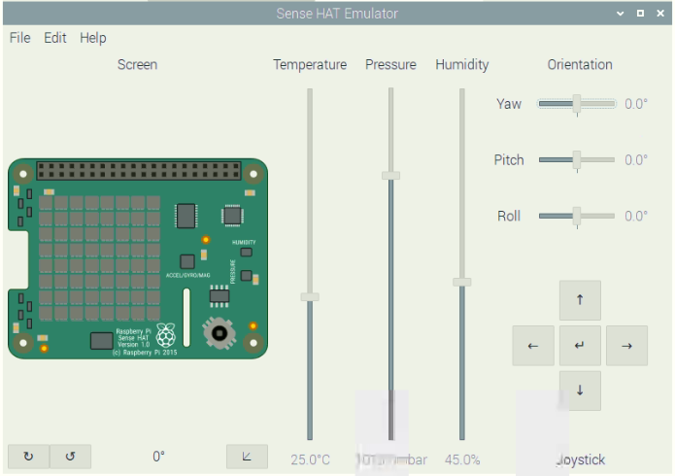

**Matrix**

Code:-

from sense_hat import SenseHat

import time

s = SenseHat()

s.low_light = True

green = (0, 255, 0)

yellow = (255, 255, 0)

blue = (0, 0, 255)

red = (255, 0, 0)

white = (255,255,255)

nothing = (0,0,0)

pink = (255,105, 180)

defraspi_logo():

G = green

R = red

O = nothing

logo = [

O, G, G, O, O, G, G, O,

O, O, G, G, G, G, O, O,

O, O, R, R, R, R, O, O,

O, R, R, R, R, R, R, O,

R, R, R, R, R, R, R, R,

R, R, R, R, R, R, R, R,

O, R, R, R, R, R, R, O,

O, O, R, R, R, R, O, O,

]

return logo

def heart():

P = pink

O = nothing

logo = [

O, O, O, O, O, O, O, O,

O, P, P, O, P, P, O, O,

P, P, P, P, P, P, P, O,

P, P, P, P, P, P, P, O,

O, P, P, P, P, P, O, O,

O, O, P, P, P, O, O, O,

O, O, O, P, O, O, O, O,

O, O, O, O, O, O, O, O,

]

return logo

images = [ raspi_logo, raspi_logo, heart, heart]

count = 0

while True:

s.set_pixels(images[count % len(images)]())

time.sleep(.75)

count += 1

Output:-

